16 Java program to display the given integer in the reverse order

Enter an integer:

547

745

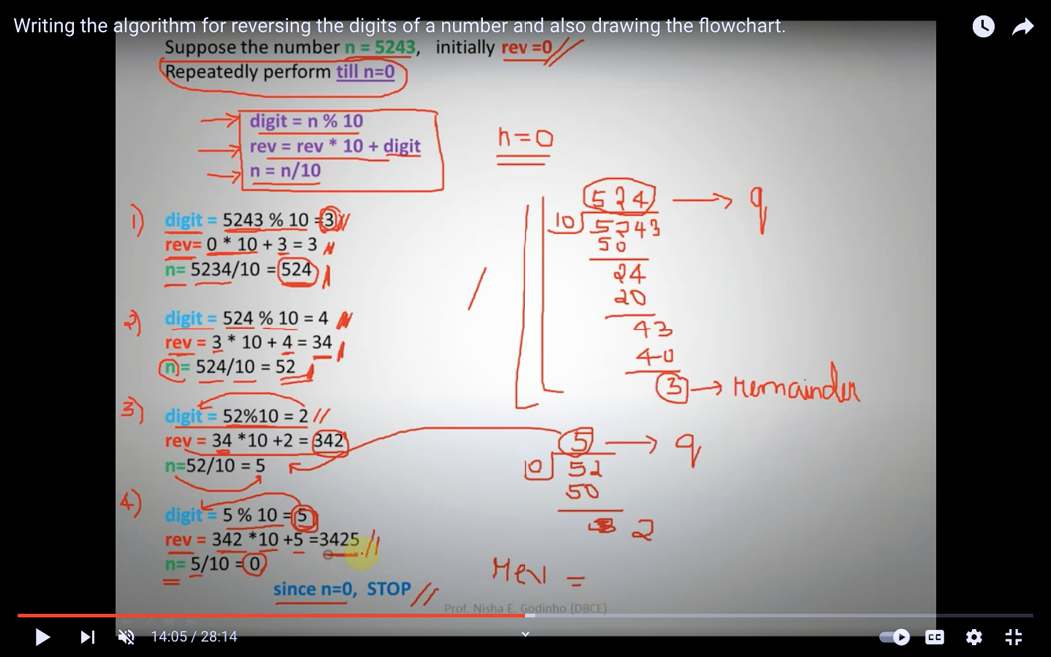

import java.util.Scanner;

public class Exercise16 {

public static void main(String[] args)

{

System.out.println("Enter an integer");

Scanner scanner = new Scanner(System.in);

int a = scanner.nextInt();

int reversenum = 0;

/////////////////////////

//while loop

while (a !=0)

{

int b = a %10;

a = a/10;

reversenum = reversenum\*10 + b;

}

System.out.println("Reverse order is"+ " " + reversenum);

}

}